

ITO 5047: Fundamentals of Artificial Intelligence

Assessment 2: Bayesian Networks

Student Name: Tristan Sim Yook Min
Student ID: 30428831

Date: 18th July 2025

Question 1: Bayesian Networks, Netica (46 marks)
Expand the Bayes Net you developed in the BN EdLab (available on Moodle under the
name Q1a-BN-SmokeAlarm.dne) to include three more events: Smoke (you can see smoke in your apartment), Evacuation (your apartment building is evacuated), and Report (the local newspaper writes a report about the evacuation of your apartment).
The probability of smoke when there is fire is 0.9, the probability of smoke when there is no fire is 0.01. When your apartment building has a fire alarm, there is a 0.88 probability that there will be an evacuation, but there is never an evacuation when there is no fire alarm. If there is an evacuation, there is a 0.75 probability that the newspaper will write a report on it, and if there is no evacuation there is a 0.99 probability that the newspaper won’t report it.
(a) Add the necessary nodes and edges to your Bayesian Networks and input the corresponding conditional probability tables. Justify your expanded network and CPTs.
(14 marks)

Answer: The Expanded Bayesian Network is implemented in Netica and is shown in the diagram below. The additional chance nodes were added into the directed acyclic graph structure to represent the emergency response to a fire.

The Smoke Node is added with a conditioning link, linking it to Fire. This is a causal relationship as the presence of smoke is the direct result of fire.

The Evacuation Node is a child node of the Alarm Node with a conditioning link too; this creates a causal chain as the alarm triggers an evacuation of the building.

The Report Node is a child node of Evacuation with a conditioning link too, as this is a causal relationship where a news report is most likely to occur following an evacuation.

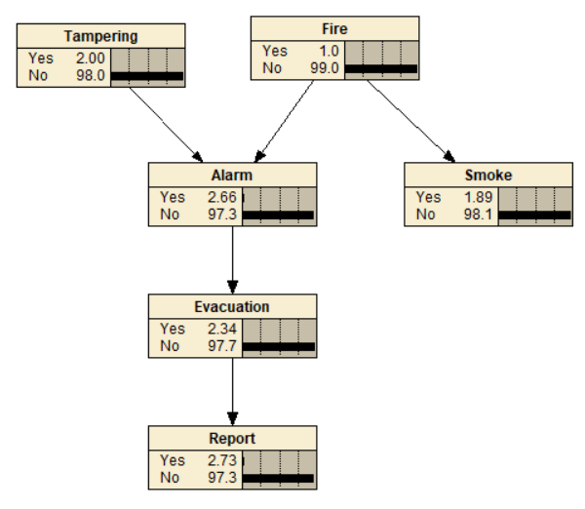

Question 1: Bayesian Networks, Netica (46 marks)

The table below shows the justification for the expanded networks:
Item | Type | Justification
Smoke | Chance Node | Represents the presence of Smoke in the building
Evacuation | Chance Node | Represents the chance of an Evacuation
Report | Chance Node | Represents the chance a newspaper coverage is made
Fire to Smoke | Conditioning Link | Fire causes the smoke to be visible
Alarm to Evacuation | Conditioning Link | The alarm alerts occupants to evacuate the building
Evacuation to Report | Conditioning Link | News Media will report emergency events

The table below shows the justification for the Conditional Probabilities Tables:
Conditional Probability Table for Smoke Node
Fire | Yes | No | Justification
Yes | 90 | 10 | When there is a fire, there is a 90% likelihood of smoke occurring
No | 1 | 99 | There is only 1% chance of smoke when there is no Fire

Conditional Probability Table for Evacuation Node
Alarm | Yes | No | Justification
Yes | 88 | 12 | When there is an Alarm, there is an 88% chance of Evacuation
No | 0 | 100 | The is Never an Evacuation if there is No Alarm

Conditional Probability Table for Report Node
Evacuation | Yes | No | Justification
Yes | 75 | 25 | There is a 75% chance the Evacuation will make a news report
No | 1 | 99 | 1% chance a news report is made when there is No Evacuation

Question 1: Bayesian Networks, Netica (46 marks)
(b) Use Netica on the expanded BN to answer the following questions: (12 marks)
i. What is the marginal probability that your smoke detector has been tampered with?

Answer: The Smoke Detector has marginal probability of 2% chance of tampering.
ii. What is the marginal probability that there will be a news report tomorrow?

Answer: The marginal probability of a news report tomorrow is 2.73%.
iii. Let’s assume that you have observed that there is smoke in your apartment. What is
the posterior probability that there will be a news report tomorrow?

Answer: The posterior probability of a news report tomorrow is 32.0%.
iv. Let’s assume that you have observed that there was no fire, and that there was a
news report about your apartment. What is the posterior probability that your smoke
detector has been tampered with?

Answer: The posterior probability that the detector has been tampered with is 53.5%.

Question 1: Bayesian Networks, Netica (46 marks)
v. Let’s assume that you have observed that there is no smoke in your apartment. What
is the posterior probability that your smoke detector has been tampered with? What
conditional independence property could help you here?

Answer: The posterior probability is 2% for the Tampering Node, unchanged from the original because Tampering Node is Conditionally Independent of Smoke Node (Tampering ⊥ Smoke).

Since the Alarm Node is the Common Effect of the Tampering and Fire Node and is Not Observed, this creates a v-structure that Blocks information from flowing between Tampering and Smoke. Therefore, observing the absence of smoke does not provide information about if the smoke detector.

Diagram on the left shows the Network with no Evidence whilst the diagram on the right shows Smoke Node being observed as No Smoke.

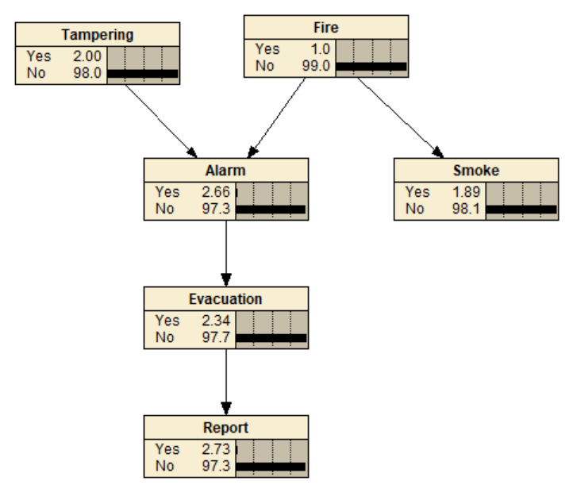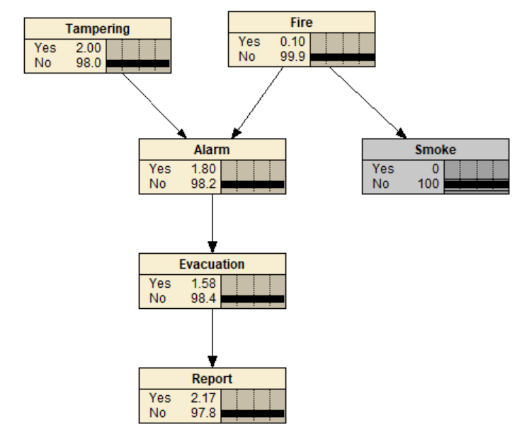

Question 1: Bayesian Networks, Netica (46 marks)
vi. Let’s assume that you have observed that there has been a news report about your
apartment, and there is no smoke in your apartment. What is the posterior probability
that your smoke detector has been tampered with? Given that the news report was
observed, why does observing the absence of smoke affect your belief of whether or not
your smoke alarm was tampered with?

Answer: The posterior probability that the smoke detector was tampered with is 51.9%.

Since a news report was made, indicating an evacuation of the building occurred due to a fire alarm. However, the alarm can only be triggered by two causes, Fire and Tampering Nodes. Before observing the absences of smoke, posterior probability for Fire was 23.7% and Tampering was 41.1%.

After observing the absence of smoke, this leaves only a 3.04% chance the alarm was triggered by the Fire, indicating Fire was an unlikely cause. This strongly suggest a 51.9% chance the smoke detector was tampered with Tampering the most likely cause.

This demonstrates the “explaining away” concept in Bayesian Networks whereby ruling out the Fire as a primary cause, the alternative cause for the alarm would strongly be the tampering of the smoke detector.

Diagram on the left shows only Report Node observed whilst the diagram on the right shows both smoke and report observed.

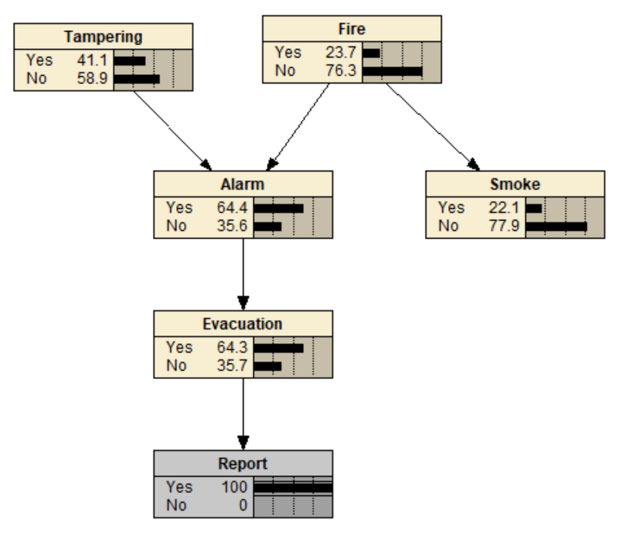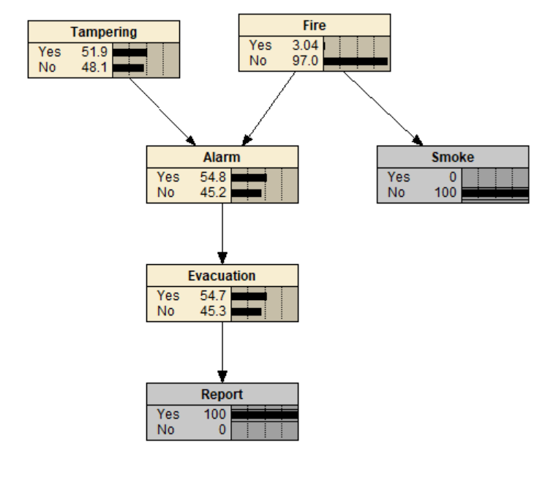

Question 1: Bayesian Networks, Netica (46 marks)
vii. Let’s assume that you have observed that there was no fire, that there was a news
report about your apartment, and that there is smoke in your apartment. What is
the posterior probability that your smoke detector has been tampered with?

How does observing whether or not there is smoke affect your belief of whether or not your smoke detector has been tampered with? Why?
Answer: The posterior probability that the smoke detector was tampered with is 53.5%.

Whilst observing the Smoke Node, be it the presence or absence of smoke, does not affect the posterior probability of the smoke detector being tampered, it remains the same at 53.5%. This is because the common cause for alarm and smoke, which is Fire, being observed as “No Fire”. This evidence of no fire, strongly suggest that the smoke detector was tampered with.

The Fire Node, being evidenced as “No Fire”, is blocking the flow of information between the Tampering Node and the Smoke Node, making them conditionally independent and d-separated given Fire.

Diagram on the left shows the Smoke Node observed with No Smoke whilst the diagram on the right shows Smoke Node Observed with Smoke.

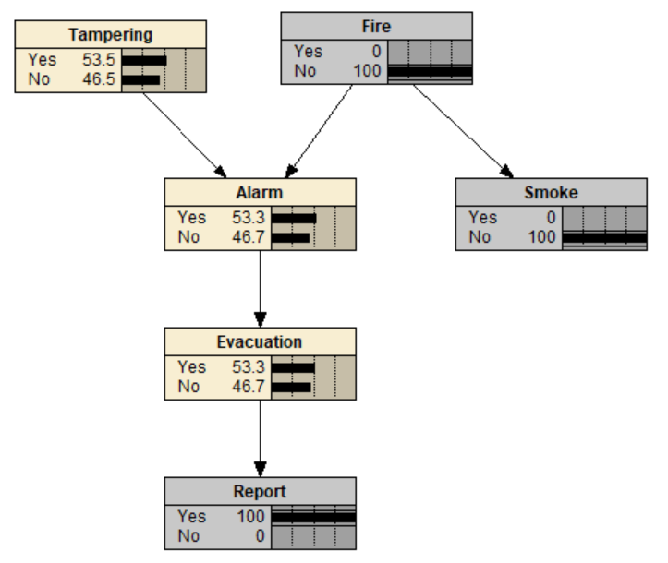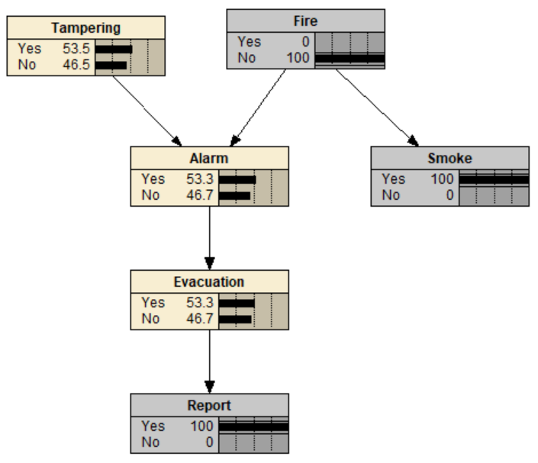

Question 1: Bayesian Networks, Netica (46 marks)

(c) Hypothesize the (conditional) independence properties of the statements below. Use Netica to check them, and state whether they are true or false. Briefly justify your answers
by indicating whether the variables in question are connected or D-separated, and which
variable(s) block or unblock the path — use the terms of Common Cause, Common Effect
and Causal Chain where applicable. (10 marks)
Note: The graph structure informs us about dependences between variables, but there
may be additional dependences based on the values of the conditional probability tables.

Tampering ⊥ Evacuation
Path | Tampering → Alarm → Evacuation
Justification | This is a Causal Chain where information can freely flow through the chain. Tampering and Evacuation are connected and dependent as information flows freely through the Alarm Node.
Answer: | False

Tampering ⊥ Evacuation | Alarm
Path | Tampering → Alarm → Evacuation
Justification | Given the Alarm Node is now observed, this is a Causal Chain is blocked. Information is not able to flow through from Tampering to Evacuation. Hence, it is conditionally independent and d-separated by Alarm.
Answer: | True

Tampering ⊥ Evacuation | Smoke
Path | (Tampering → Alarm ← Fire → Smoke) (Alarm → Evacuation)
Justification | When Smoke is observed, it provides evidence for Fire. Both Alarm and Smoke have a Common Cause which is Fire. Hence, if probability for Fire changes, it will directly affect Alarm. However, this does not affect the information flow between Tampering and Evacuation because of the existing Casual Chain making them dependent.
Answer: | False

Tampering ⊥ Fire
Path | Tampering → Alarm ← Fire
Justification | This path is a Common Effect and when Alarm is Not Observed, the v-structure Blocks between Tampering and Fire Node, making Tampering and Fire connected but independent of each other.
Answer: | True

Tampering ⊥ Fire | Alarm
Path | Tampering → Alarm ← Fire
Justification | This path is a Common Effect and since Alarm is Now Observed, the path is now Unblocked and information can flow between Tampering and Fire Node, making them conditionally dependent given Alarm.
Answer: | False
Question 1: Bayesian Networks, Netica (46 marks)

Alarm ⊥ Smoke
Path | Smoke ← Fire → Alarm
Justification | Fire is a Common Cause for both Alarm and Smoke and since it is Not Observed, the information flow is not blocked. Therefore, Alarm and Smoke are connected and dependent as information can freely flow.
Answer: | False

Smoke ⊥ Report
Path | (Smoke ← Fire → Alarm) (Alarm → Evacuation → Report)
Justification | The path between Smoke and Report goes through a Common Cause (Smoke ← Fire → Alarm) and the followed by a Casual Chain (Alarm → Evacuation → Report). Since No Nodes are observed along this path, the information is not blocked and can flow freely through them. Smoke and Report are connected and dependent because the common cause and casual chain paths are bridging the information together.
Answer: | False

Smoke ⊥ Tampering
Path | (Tampering → Alarm ← Fire → Smoke)
Justification | The Fire Node is a Common Cause for both Alarm and Smoke Node. The Alarm Node is a Common Effect and has two causes which is Tampering and Fire. Naturally, information is blocked at the Alarm Node when it is not observed and means that the Tampering and Smoke Node are independent of each other.
Answer: | True

Smoke ⊥ Tampering | Alarm
Path | (Tampering → Alarm ← Fire → Smoke)
Justification | Given that the Alarm Node is observed, this Common Effect v-structure between Fire and Tampering Node, is Unblocked and allowing the flow of information between Smoke and Tampering Node making them conditionally dependent.
Answer: | False

Smoke ⊥ Tampering | Report
Path | (Tampering → Alarm ← Fire → Smoke) (Alarm → Evacuation → Report)
Justification | When Report is Observed, it indirectly provides evidence to Evacuation which in turn provides evidence to Alarm, because this a Casual Chain. Through the explaining away affect, Alarm getting partially evidenced and being a Common Effect of Tampering and Fire, unblocks information between Smoke and Tampering nodes making them conditionally dependent given Report
Answer: | False
Question 1: Bayesian Networks, Netica (46 marks)
(d) Based on your BN, construct a Bayesian Decision Network (BDN) that decides whether
the building should be evacuated. That is, instead of having an Evacuation chance node,
you should have a decision node that determines whether you should evacuate the building. Specify and justify the information links and the values in the utility node.
Answer: This Answer is Attached as “Q1d-BN-SmokeAlarm.dne”

The Evacuation node has been changed to a decision node to determine if occupants should evacuate the building. The evacuation node receives information from both alarm and smoke nodes, as occupants can react to the fire alarm and observe the presence of smoke to directly infer the likelihood of an actual fire. Unlike smoke and alarm, the fire and the tampering may not be immediately known to the occupants. The Utility Node depends on fire which is the actual danger and the evacuation which is the decision taken in response to said danger. The utility score depends on the positive/negative relationship between the outcome and actions. The Utility Node information is tabulated below.

Utility Node
Fire | Evacuation | Utility | Justification
Yes | Yes | 100 | Maximum Utility as Residents Must Evacuate during a Fire
Yes | No | -100 | Worse Possible Utility occupants did not Evacuate and Danger
No | Yes | -20 | Fairly Poor Utility as there was a False Alarm Triggered
No | No | 50 | Normal Utility as No Fire means No Alarm is Triggered

With no evidence, the decision to evacuate is “No” with an expected utility of 48.5%. The bottom left diagram shows when the occupants hear the alarm but observe no smoke, the decision to evacuate is still “No” with an expected utility of 41.7% suggesting it may be a false alarm. However, in the bottom right diagram, when there is smoke and the alarm has been triggered, the decision to evacuate is “Yes” with an expected utility of 97.7%, maximizing utility to evacuate due to the likeness of an actual fire.

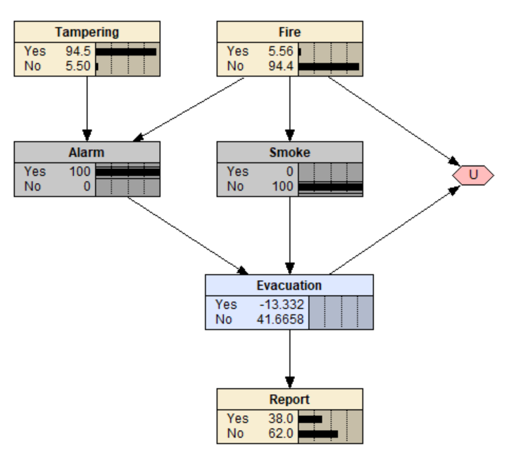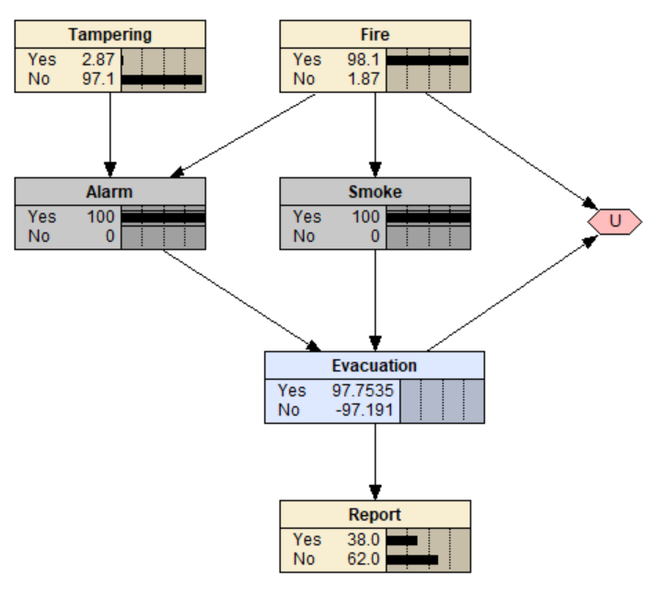

Question 2: Bayesian Networks, Netica (28 marks)
It is coming to the end of winter and Ron is trying to model the factors that affect the state
of his lawn. The lawn is currently looking pretty sad, as his children spent all last summer
playing backyard cricket and have worn several bare patches. However, the area has been in drought for the previous 12 months. If there is no rain before summer, it will be very hard to get the new lawn to grow, and Ron will waste a lot of time and money. Furthermore, if there is no rain, the authorities could increase the level of water restrictions, meaning that Ron will be unable to water his lawn at all. This would make the chances of his lawn surviving very small indeed. To further complicate the matter, there is a small chance that the area could experience another frost before the weather warms up, which also could damage the new lawn.

- Design a BN using the nodes: Rain, LawnGrow, WaterRestrictions and Frost. Justify your design (9 marks).

Answer: The Network Structure designed in Netica is shown in the diagram below and attached in the Assignment Submission as “Q2-BN-LawnState”. The network models a causal relationship between the healthy growth of the lawn and external factors.

Rain serves as the Parent Node for Water Restrictions and Lawn Growth. The absence of rain increases the probability of the authorities enacting water restricting policies whilst reducing likelihood of a successful lawn growth. If water restrictions measures were to be implemented, it will further reduce the chances of regrowing the lawn by preventing the owner from watering the lawn. Additionally, Frost during winter is another factor that can adversely affect the healthy regrowth of the lawn.

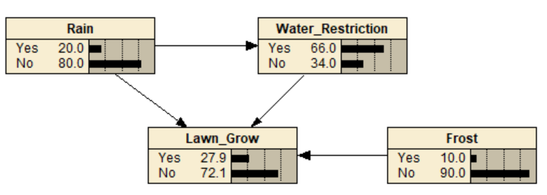

The table below shows the justification for the networks design:
Item | Type | Justification
Rain | Chance Node | Represents the Chance of Raining
Water Restrictions | Chance Node | Represents the Chance of Water Restrictions
Lawn Grow | Chance Node | Represents the Chance for Law to Grow
Frost | Chance Node | Represents the Chance of Frost during Winter
Rain to Water Restrictions | Conditioning Link | Rain Reduces the likelihood of Water Restrictions
Rain to Lawn Grow | Conditioning Link | Rain Increases the chances of lawn growth
Water Restriction  to Lawn Grow | Conditioning Link | Water Restrictions take effect; it can reduce the chances of watering and regrowing the Lawn
Frost to Lawn Grow | Conditioning Link | Frost reduces the chances of lawn growth
Question 2: Bayesian Networks, Netica (28 marks)

- Inspect your BN and report on any value assignments that will cause D-separation between any sets of nodes. Explain why this is the case in terms of Common Cause, Common Effect and Causal Chain. (6 marks)

Answers:

For the Rain Node → Water Restrictions Node, they are dependent and are connected through a Casual Chain relationship. Observing the Rain will directly affect the posterior probability of water restrictions, as the lack of rain will increase the chances of water restriction measures being imposed.

For the Lawn Grow Node, its probability is connected and dependent to all its parent node which are Rain, Water Restrictions and Frost. All three parent nodes have direct Casual Chain relationship to Lawn Grow, where each parent node will directly affect the probability of a successful lawn growth. Moreover, the Lawn Grow Node is a Common Effect of all three parents. When Lawn Grow is observed, it unblocks information flow between Frost, Water Restrictions and Rain making them conditionally dependent.

Table below further explains the individual relationships between nodes:

Rain ⊥ Frost
Path | (Rain → Lawn Grow ← Frost)
Justification | Lawn Grow is a Common Effect of Rain and Frost, due to this V-structure, information is blocked when Lawn Grow is unobserved, making Rain and Frost independent.

Rain ⊥̸ Frost | Lawn Grow
Path | (Rain → Lawn Grow ← Frost)
Justification | Lawn Grow is a Common Effect of Rain and Frost. When Lawn Grow is Observed, it unblocks the v-structure and information flows between Rain and Frost, making them conditionally dependent.

Water Restrictions ⊥ Frost
Path | (Water Restrictions → Lawn Grow ← Frost)
Justification | Lawn Grow is a Common Effect of Water Restrictions and Frost, due to this V-structure, information is blocked when Lawn Grow is unobserved, making Water Restrictions and Frost independent.

Water Restrictions ⊥̸ Frost | Lawn Grow
Path | (Water Restrictions → Lawn Grow ← Frost)
Justification | Lawn Grow is a Common Effect of Water Restrictions and Frost. When Lawn Grow is Observed, it unblocks the v-structure and information flows between Water Restrictions and Frost, making them conditionally dependent and connected.

Question 2: Bayesian Networks, Netica (28 marks)

- Quantify the relationships in the network by adding numbers for the CPTs. Justify the
numbers in your CPTs (6 marks)

The table below shows the justification for the Conditional Probabilities Tables:
Conditional Probability Table for Rain Node
Yes | No | Justification
20 | 80 | Given that the area has been in drought for the past 12 months, the probability of adequate rain for regrowing the lawn is low. A 20% probability of rain is assumed to allow for some possibility of rain to occur due to weather changes.

Conditional Probability Table for Frost Node
Yes | No | Justification
10 | 90 | The statement mentioned there is a small chance of Frost during winter, which has an adverse effect on the lawn growth by damaging lawn.

Conditional Probability Table for Water Restriction Node
Rain | Yes | No | Justification
Yes | 10 | 90 | When there is Rain, there is little chance of Water Restrictions being enacted; however, a small chance exists for unexpected scenarios like the Water Distribution Plant due to technical issues
No | 80 | 20 | When there is No Rain for extended periods of time, it is very likely that Water Restrictions Measures may be put in place

Conditional Probability Table for Lawn Grow Node
Rain | Water Restrictions | Frost | Yes | No | Justification
Yes | Yes | Yes | 70 | 30 | Rain waters the lawn, regardless of water restrictions, but Frost might damage the lawn
Yes | Yes | No | 80 | 20 | Rain waters the lawn, regardless of water restrictions and no Frost means no damage
Yes | No | Yes | 75 | 25 | Rain waters the lawn but Frost would mean damage to the Lawn
Yes | No | No | 90 | 10 | Lawn has a high chance of growing healthy since there is Rain, No Water Restrictions and No Frost
No | Yes | Yes | 0 | 100 | No Rain combined with Water Restrictions and Frost results in the Lawn Not Growing
No | Yes | No | 10 | 90 | No Rain combined Water Restrictions means there is a slim chance of the lawn regrowing
No | No | Yes | 20 | 80 | No Rain and No Water Restrictions means the owner may still water the lawn, but Frost will still damage the lawn
No | No | No | 30 | 70 | No Rain and No Frost but having No Water Restrictions means the owner may still water lawn, increasing the likelihood of survival

Question 2: Bayesian Networks, Netica (28 marks)

- Using Netica, demonstrate the workings of your BN by determining the probability of the lawn growing in the following cases.

- There is no evidence. (1 mark)

Answer: Lawn Growing Successfully Probability: 27.9%

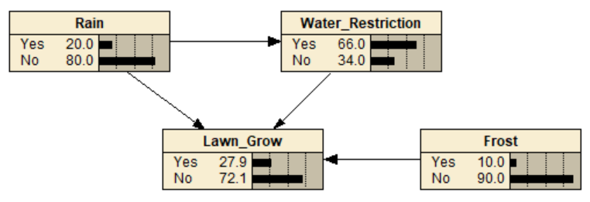

- There is no rain, and water restrictions have been applied. Explain your results com-
pared to item 1. (3 marks)

Answer: Lawn Growing Successfully Probability: 9.0%.

In this scenario, we know that for the whole year, there was No Rain and Water Restrictions Measures were enacted. These observations provide evidence to the Lawn Grow to Grow Successfully as that there was no chance of Rain and watering due to Water Restrictions measures. The diagram below shows the calculated probability.

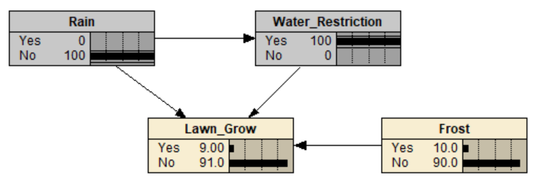

In Question d.1), no nodes were observed, the default Conditional Probability Tables of each Chance Node gives a more optimistic outlook that there was still a 20.0% chance of Rain occurring that year and a 66.0% chance of Water Restrictions being imposed. Given the more optimistic outlook, the posterior probability of Lawn Growing to be Successful is 27.9%.

Question 2: Bayesian Networks, Netica (28 marks)

- There is frost, but it has rained. Explain your results compared to item 1. (3 marks)

Answer: Lawn Growing Successfully Probability: 74.5%.

Since it is observed that it has rained, there is also a much lower likelihood of water restrictions measures being taken. This increases the chances of the lawn growing successfully significantly. However, due to frost occurring over the winter, it has an adverse effect on Lawn Growth by damaging the lawn and reduces the posterior probability of lawn growing successfully slightly.

It is important to note that greatest determinant of the successful growth of the lawn is the presence of Rain. From the Conditional Probability Table of the Lawn Grow Node, rain contributes a larger proportion of its success. Frost, on the other hand, albeit having a detrimental effect, was mentioned to have a “small chance” of occurring. Additionally, the presence of rain also reduces the likelihood of water restrictions which, in turns increases the chances of the lawn growing successfully as there is an additional water source to water the lawn.

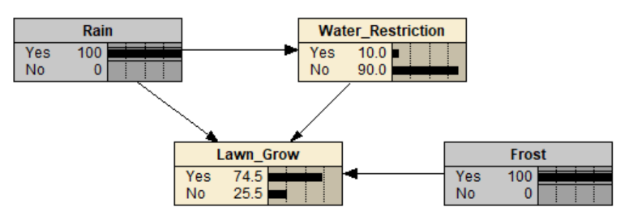

Compared to Question d.1), where the default probability was a 20.0% chance of rain occurring that year and water restrictions had a 66.0% chance of being enforced, the posterior probability for lawn growing successfully was much lower at 27.9% since there was still the looming possibility of no rain and water restrictions being very likely to be enforced. No evidence was available to suggest rain was coming.

Question 3: D-separation (26 marks)
Consider the following Bayesian Network called Q3ab-BN-rental2.dne (available on Moodle)
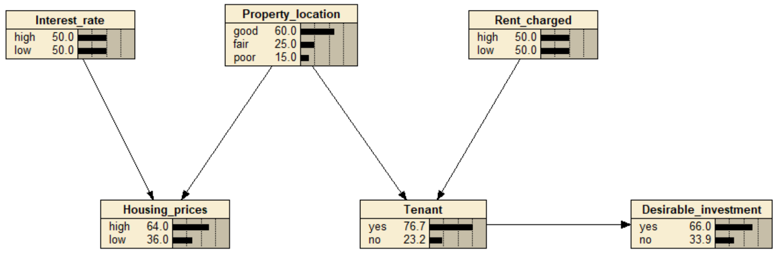
- List the conditions under which you will be able to propagate evidence from Interest rate to Rent charged. That is, which nodes need to be instantiated or uninstantiated so that evidence can be propagated from Interest rate to Rent charged. Explain why this is the case using the terms Common Cause, Common Effect and Causal Chain where applicable. (12 marks)
Interest Rate to Rent Charged
Condition 1 |  | Housing Prices and Tenant Are Instantiated
Network Path |  | (Interest Rate → Housing Prices ← Property Location → Tenant ← Rent Charged)
Instantiated | Uninstantiated | Explanation
Housing Prices, Tenant | Property Location, Interest Rate, Rent Charged, Desirable Investment | When Housing Prices are observed, it acts as a Common Effect of both Interest Rate and Property Location, this unblocks the v-structure and allows the information to propagate from Interest Rate to Tenant, making them conditionally dependent.  Moreover, the Tenant Node is a Common Effect of Property Location and Rent Charged, creating another v-structure. Observing Tenant will unblock the flow of information between Interest Rate and Rent Charged, making them conditionally dependent and connected.
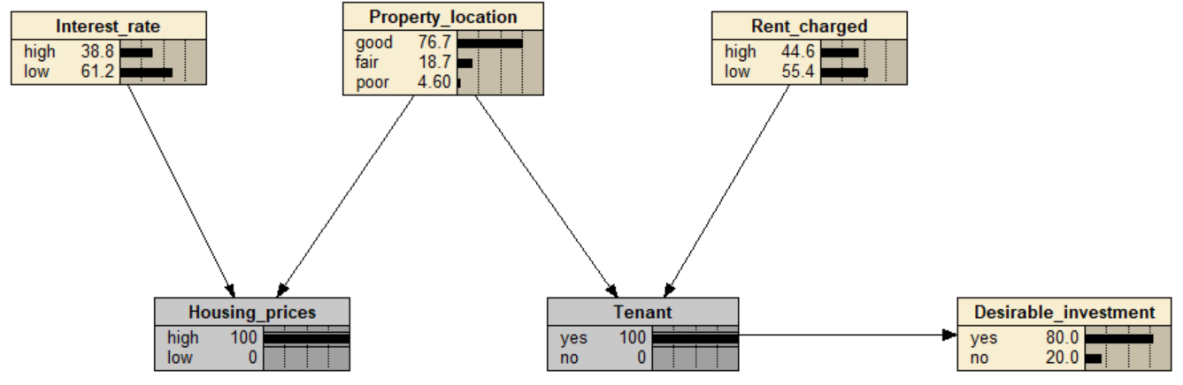

Question 3: D-separation (26 marks)

Interest Rate to Rent Charged
Condition 2 |  | Housing Prices and Desirable Instantiated
Network Path |  | (Interest Rate → Housing Prices ← Property Location → Tenant ← Rent Charged) (Tenant → Desirable Investment)
Instantiated | Uninstantiated | Explanation
Housing Prices, Desirable Investment | Property Location, Interest Rate, Rent Charged, Tenant | Similarly, observing the common effect node, Housing Prices will unblock the v-structure, allowing information to propagate from Interest Rate to Tenant.  Interest Rate remains independent from Rent Charged due to Tenant, which is a Common Effect of Property Location and Rent Charged. When Tenant is not observed, the information cannot propagate from Interest Rate and Rent Charged.  When Desirable Investment is observed as “Yes”, this provides strong evidence and is passed up to its parent node, Tenant, through a Causal Chain relationship. This in turn unblocks the v-structure by partially activating Tenant, allowing information to pass through between Interest Rate and Rent Charged, making them conditionally dependent.  However, when Desirable Investment is observed as “No”, the weaker evidence insufficient to activate the Tenant, resulting information being blocked between Interest Rate and Rent Charged.
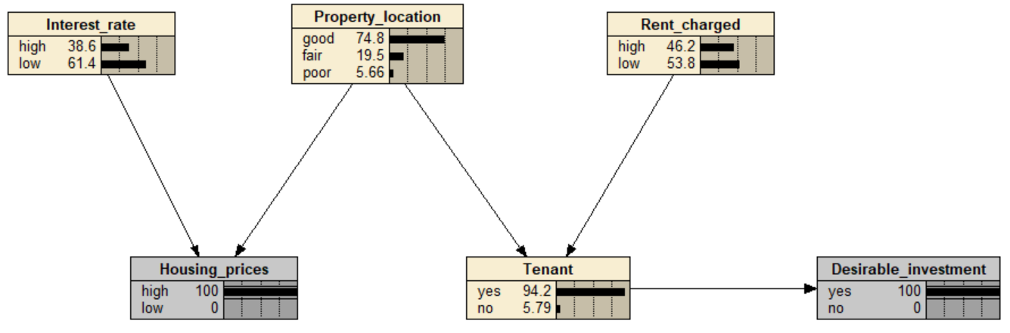

Question 3: D-separation (26 marks)

Interest Rate to Rent Charged
Condition 3 |  | Housing Prices, Tenant and Desirable Instantiated
Network Path |  | (Interest Rate → Housing Prices ← Property Location → Tenant ← Rent Charged) (Tenant → Desirable Investment)
Instantiated | Uninstantiated | Explanation
Housing Prices,  Tenant, Desirable Investment | Property Location, Interest Rate, Rent Charged | Following up from Condition 2, if Desirable Investment is observed as “No”, it has insufficient evidence to unblock the flow of information at the Tenant Node. Which is the cause of Interest Rate and Rent Charged, remaining independent.  In this 3rd Condition, an additional node, the Tenant Node is observed. Observing Tenant unblocks the v-structure of the common effect, Property Location → Tenant ← Rent Charged.  Ultimately, observing all three nodes, Housing Prices, Tenant and Desirable Investment, when the case of Desirable Investment is “No” permits the propagation of information between Interest Rate and Rent Charged, resulting in them being conditionally dependent and connected.
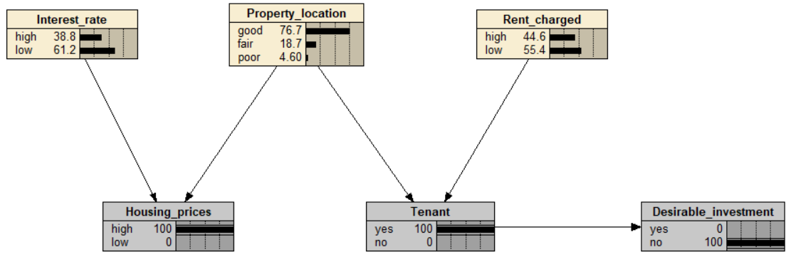

Question 3: D-separation (26 marks)

- Repeat question (a) for propagating evidence from Desirable investment to Housing prices. Explain why this is the case using the terms Common Cause, Common Effect and Causal Chain where applicable. (6 marks)

Desirable Investment to Housing Prices
Condition 1 |  | No Node is Instantiated
Network Path |  | (Desirable Investment ← Tenant ← Property Location → Housing Prices)
Instantiated | Uninstantiated | Explanation
None | Rent Charged, Property Location, Interest Rate,  Housing Prices,  Tenant,  Desirable Investment | No Nodes need to be Instantiated here for Desirable Investment to Propagate Information up to the Housing Prices.  This is because Desirable Investments has a direct conditional link to Tenant through a Causal Chain.  Tenant is Common Effect of its parent nodes, Property Location and Rent Charged, meaning if the probability of Tenant is altered by evidence from Desirable Investment, it will directly influence them too.  When the posterior probability for Tenant Node updated, Property Location will be given evidence and updated as well.  Ultimately, Property Location will propagate the information down to its child node, Housing Prices, which is connected to it through a Common Cause Relationship, where Property Location is a parent of Housing Prices.  Hence, Desirable Investment is conditionally dependent and connected to Housing Prices.
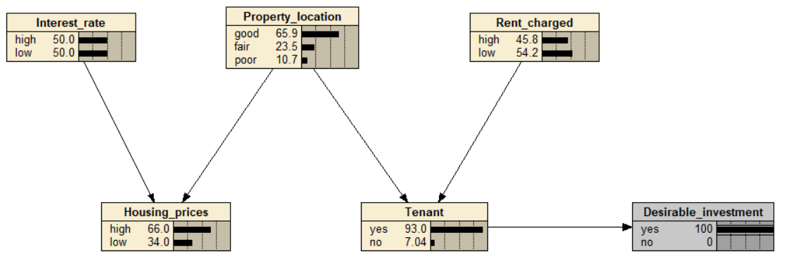

Question 3: D-separation (26 marks)

- Repeat the above questions under the assumption that there is also an arc from Housing prices to Tenant (the corresponding BN, Q3c-BN-rental3.dne, is available on Moodle). Provide explanations using the terms Common Cause, Common Effect and Causal Chain where applicable. (8 marks)
Interest Rate to Rent Charged
Condition 1 |  | Tenant is Instantiated
Network Path |  | (Interest Rate → Housing Prices ← Property Location → Tenant ← Rent Charged) (Housing Prices → Tenant ← Rent Charged)
Instantiated | Uninstantiated | Explanation
Tenant | Property Location, Interest Rate, Rent Charged, Desirable Investment | In this new network structure, for Interest Rate to directly influence Rent Charged is by observing the Tenant Node.  Interest Rate and Property Location are Parent Nodes to Housing Prices, connected a Common Effect, indicating any evidence will directly influence the Housing Price.  Moreover, the New Arc introduces a new conditioning link for information to flow between Housing Prices and Tenant creating a Causal Chain Relationship, in addition to the existing Common Cause structure.  However, Rent Charged and Property Location are connected to Tenant as Common Effect relationship. This v-structure will naturally block information flow between its parent node when Tenant is unobserved.  However, when Tenant Node is observed, the information becomes unblocked at the v-structure and can freely flow, making Interest Rate and Rent Charged conditionally dependent and connected.
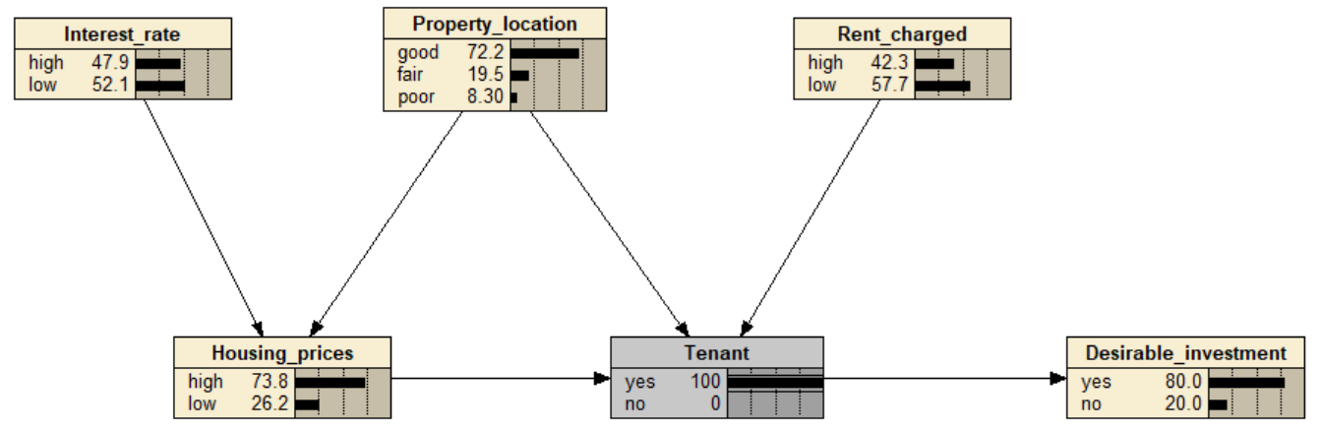

Question 3: D-separation (26 marks)

Desirable Investment to Housing Prices
Condition 1 |  | No Node is Instantiated
Network Path |  | (Desirable Investment ← Tenant ← Housing Prices)
Instantiated | Uninstantiated | Explanation
None | Rent Charged, Property Location, Interest Rate,  Housing Prices,  Tenant,  Desirable Investment | Similar like before, No Nodes need to be Instantiated here for Desirable Investment to Propagate Information up to the Housing Prices.  Desirable Investments has a direct conditional link to Tenant through a Causal Chain.  The new conditionally link, linking Housing Prices and Tenant creates a new Causal Chain Relationship, making a direct information connection flow from Desirable Investment through Tenant to Housing Prices.  Hence, no nodes need to be observed for Desirable Investment to pass information to Housing Prices.
